**A Details of the design, architecture, microservices, database scripts, code, unit test cases for this project.**

**Introduction**

Welcome to an e-commerce platform built using Flask!

Our website offers a wide range of products and services, providing customers with a seamless shopping experience.

Using Flask, we have developed a fast, reliable, and secure platform that ensures smooth transactions and a user-friendly interface. Our goal is to provide you with a convenient and enjoyable shopping experience, right from the comfort of your home.

Explore our website to discover amazing deals, exciting offers, and a diverse collection of products. Join us in revolutionizing the online shopping experience with Flask!

**Scope**

The e-commerce website project aims to create a robust online platform for selling a variety of products to customers worldwide. The scope includes developing a user-friendly interface for browsing products, adding items to cart, and completing purchases. Additionally, the project includes features for user authentication, order management, and inventory tracking.

**Target Audience**

The target audience for the e-commerce website includes individuals of all ages and backgrounds who are looking to purchase products online. The website caters to a wide range of interests and preferences, offering a diverse selection of products to meet the needs of different customer segments.

**Technologies Used**

The e-commerce website is built using Flask, a lightweight and efficient web framework for Python. Flask provides a flexible and scalable architecture for developing web applications, making it ideal for this project. The website also utilizes SQLite for database management, providing a reliable and efficient storage solution. Additionally, the website incorporates HTML, CSS, and JavaScript for front-end development, ensuring a responsive and interactive user experience.

**Design and Architecture**

**Overall Architecture**

The e-commerce website follows a client-server architecture, where the Flask application serves as the server-side logic, handling client requests and interacting with the database. The front-end is built using HTML, CSS, and JavaScript, providing a responsive and interactive user interface.

**Design Patterns**

mvc the application follows the MVC design pattern, separating the presentation layer (View) from the business logic (Controller) and data (Model). This allows for easier maintenance and scalability.

**# Shopping Cart**

A simple E-commerce website using Flask.

**## Dependencies ##**

1. Python3

2. Flask

3. Sqlite

**## How to run ##**

1. Set up database by running database.py

2. Run python main.py

3. Enter localhost:5000 in the browser

**## Pipenv instructions ##**

1. Install pipenv (python3 -m pip install --user pipenv)

2. Install dependencies (pipenv install --dev)

3. Setup database (pipenv run python database.py)

4. Run the server (pipenv run python main.py)

5. Enter localhost:5000 in the browser

**## Sample User ##**

Sample credentials present in existing database:

Username - sample@example.com

Password – sample

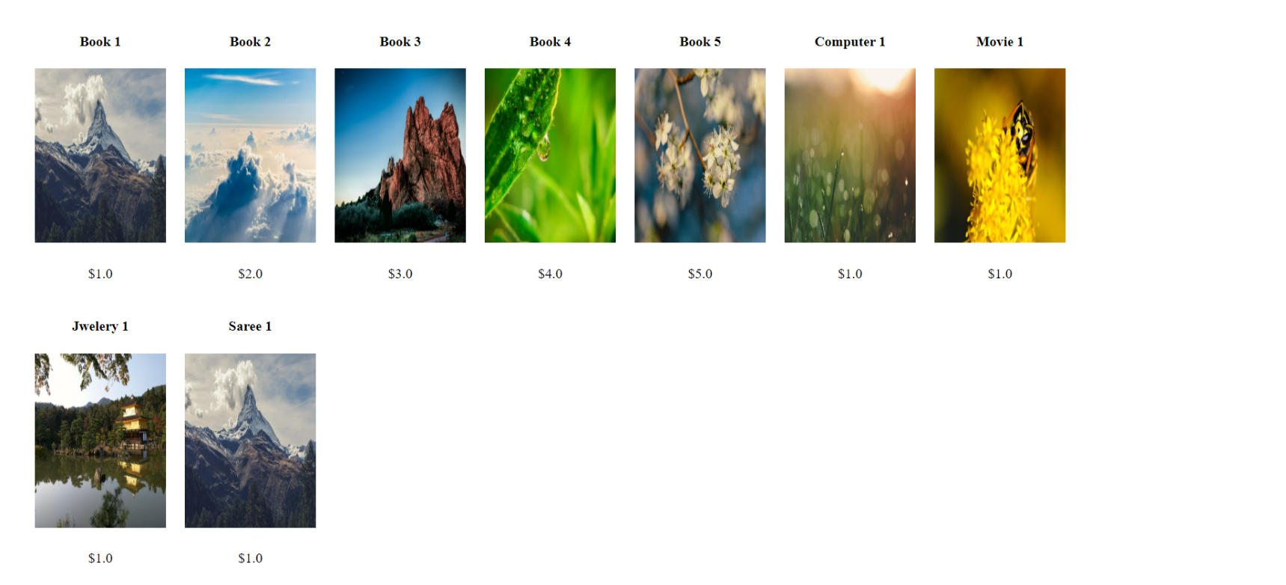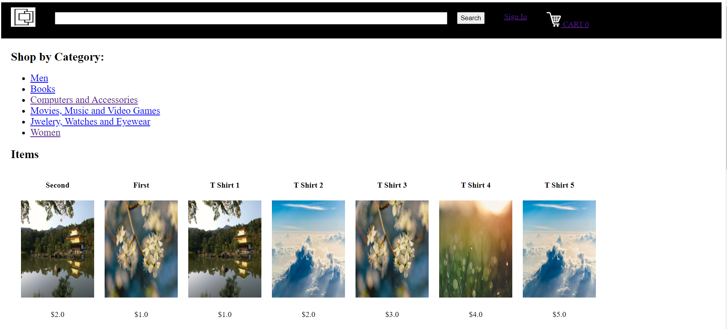**Home page of website**

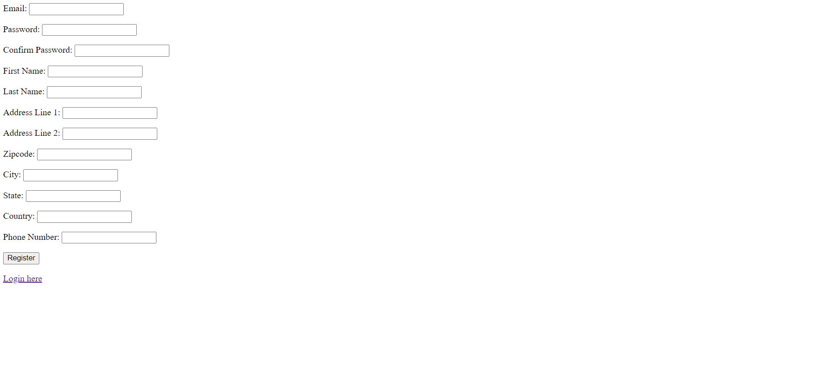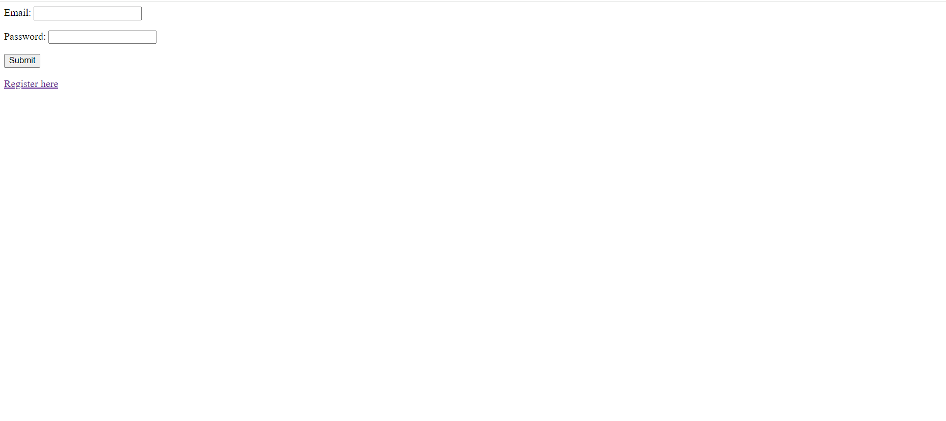**Create profile for the user**

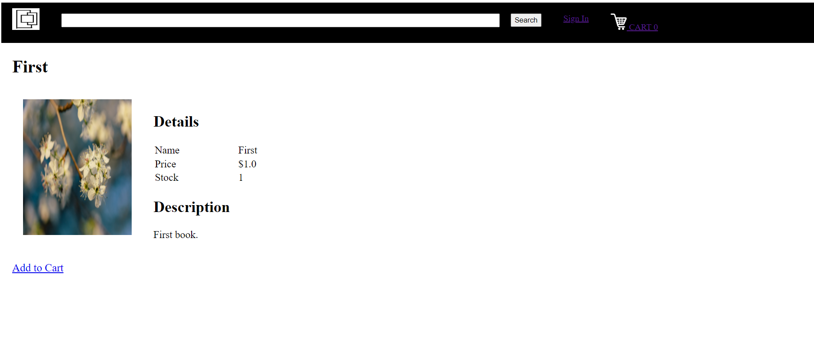**Add item to the cart**

**Invalid user name and password page**

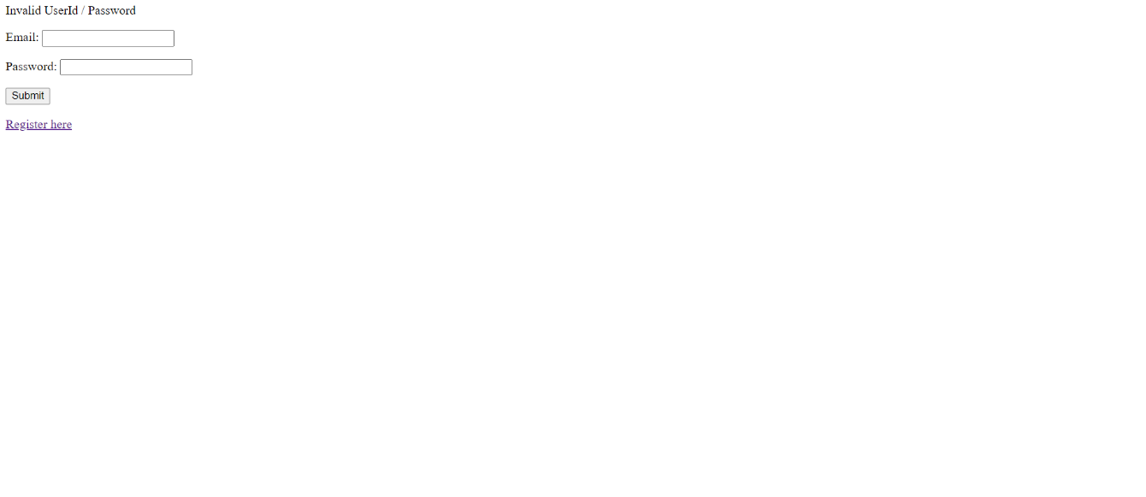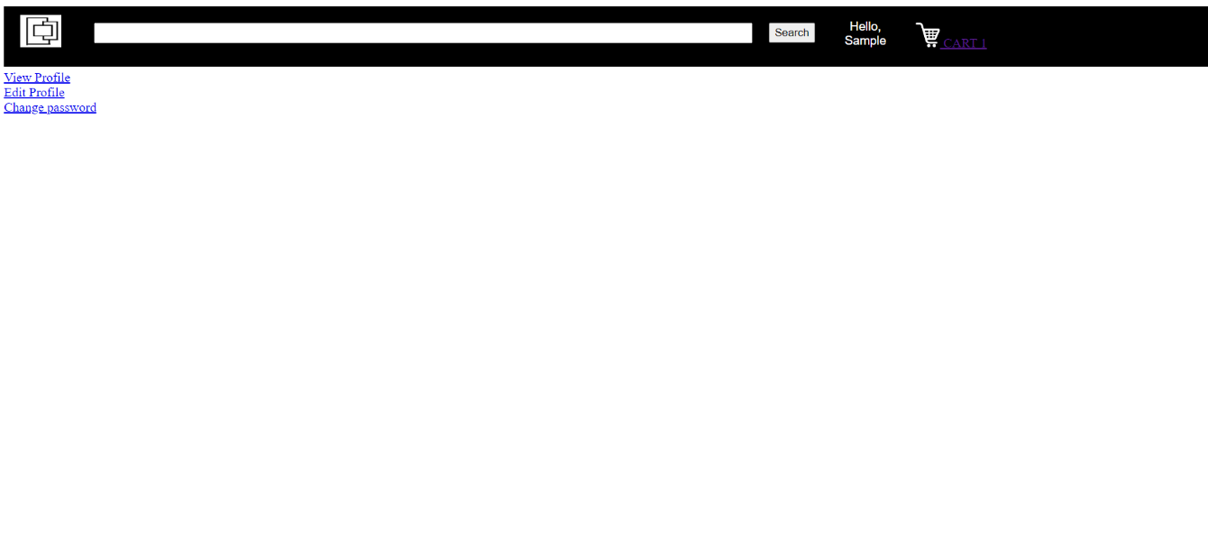

**View profile, edit profile and change password section, user may change their profile.**

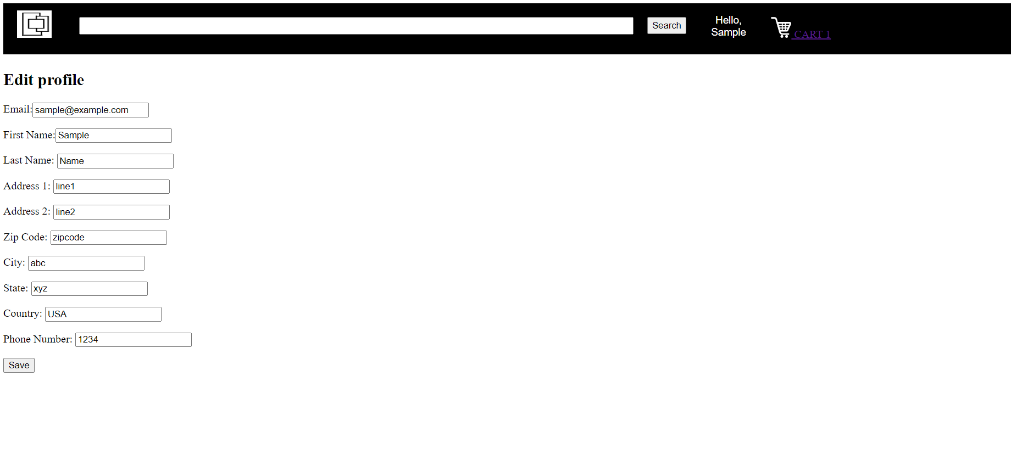Add profile details

**Microservices Architecture Overview**

**Service Boundaries**

* **User Service: Manages user authentication, registration, and profile management.**
* **Product Service: Handles product-related functionalities such as adding, removing, and updating products.**
* **Order Service: Manages orders, including order creation, updating order status, and order history.**
* **Cart Service: Deals with operations related to the shopping cart, such as adding, removing, and updating items in the cart.**
* **Category Service: Manages product categories and provides functionalities to list products by category.**

**Code snippet- This is login HTML page code snippet**

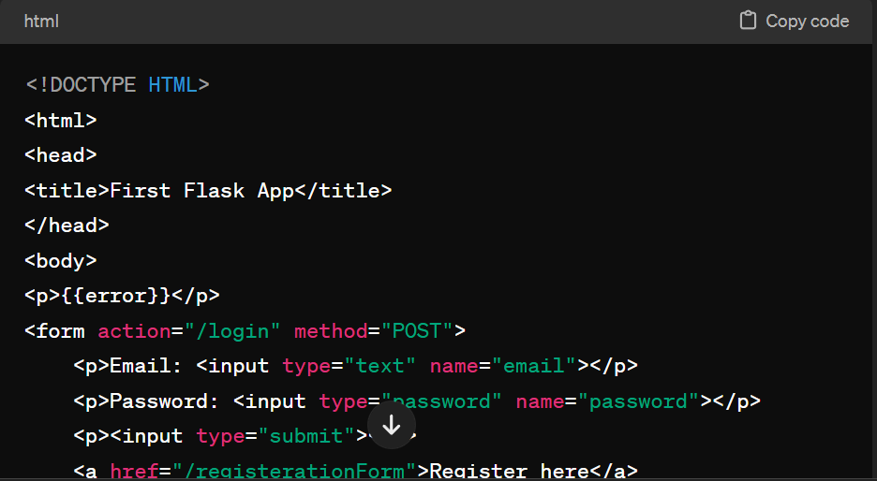

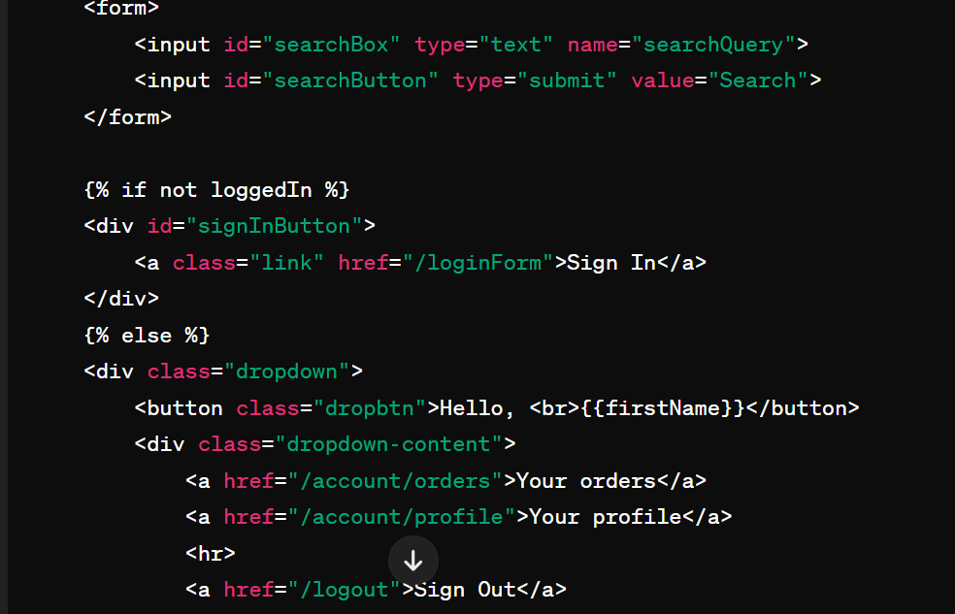**create display page snippet**

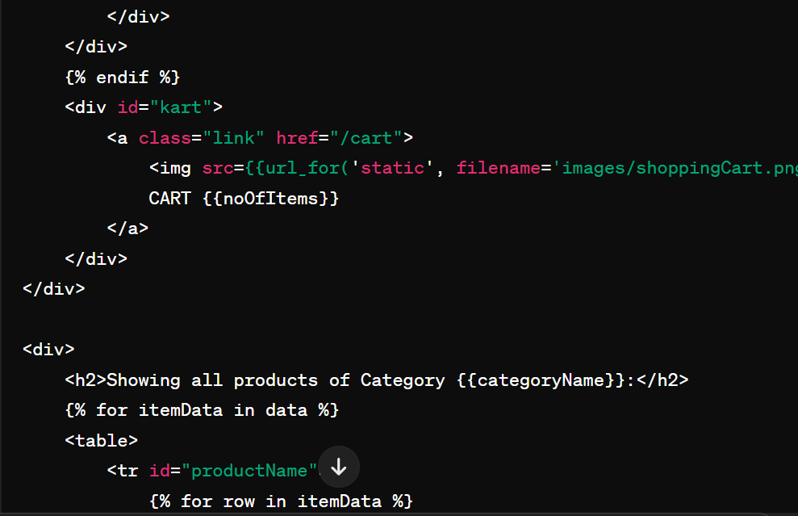

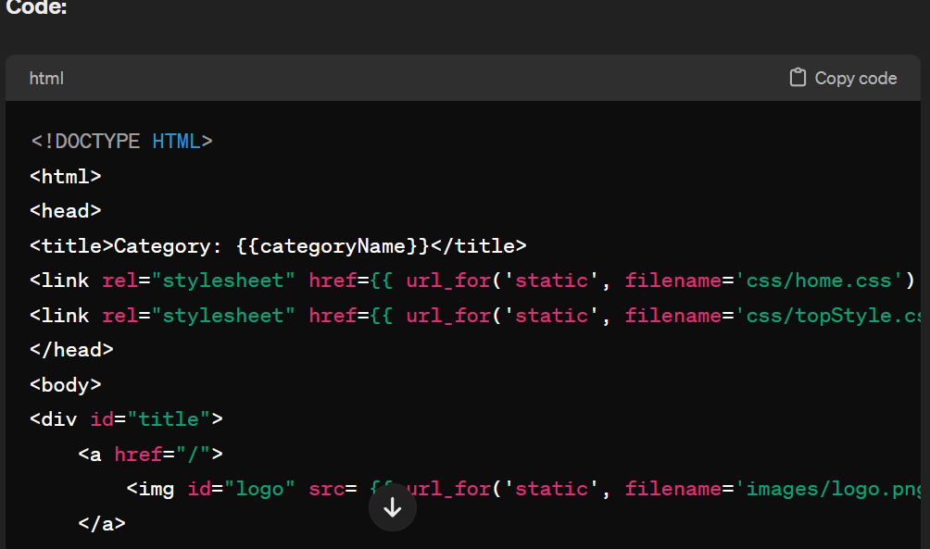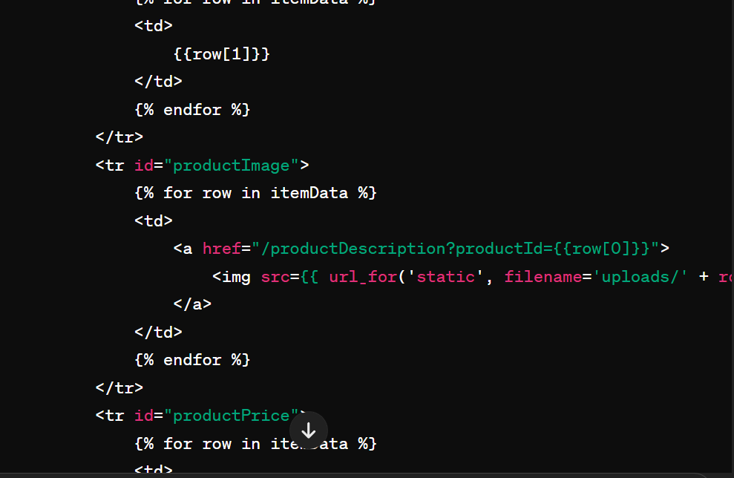

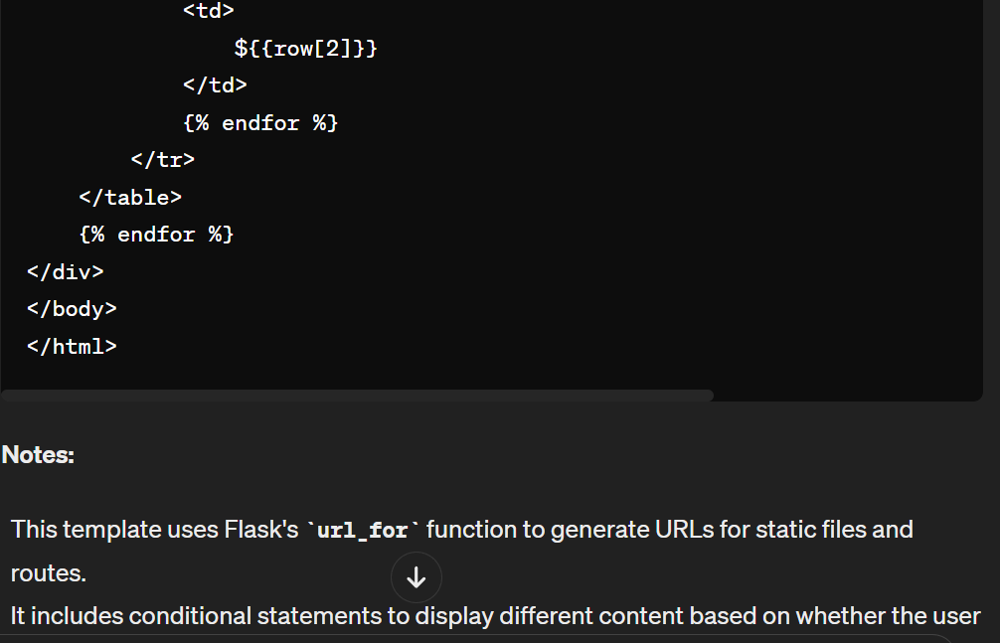

**Change password page snippet**

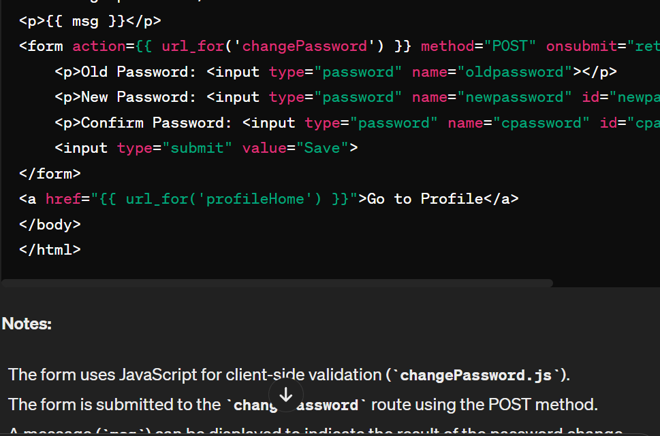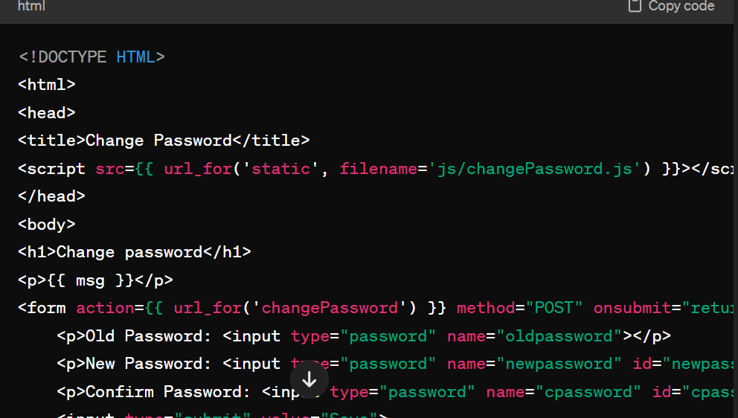

**Card HTML page-**

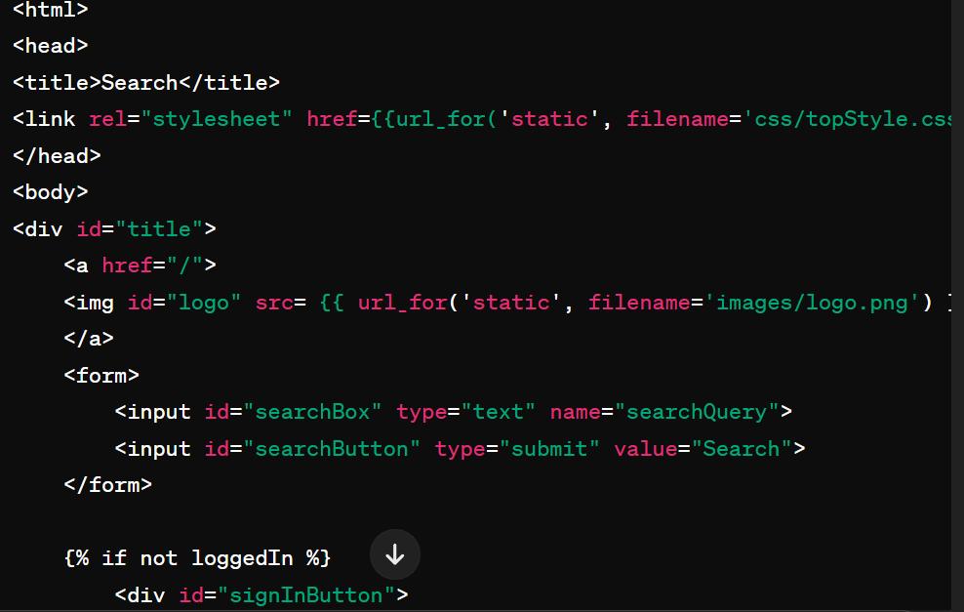

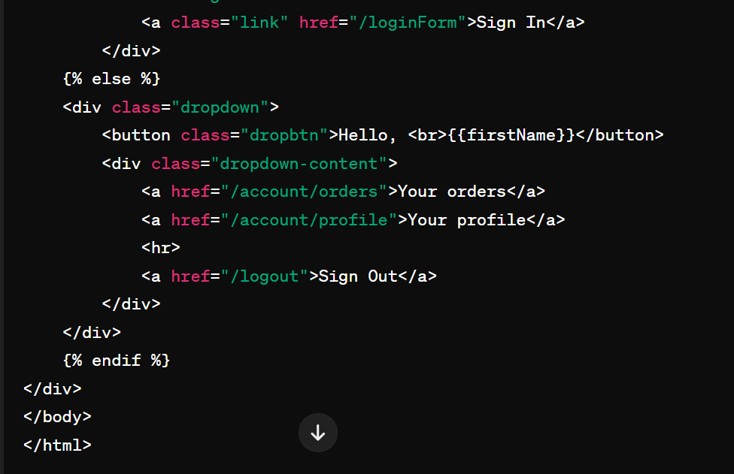

**Add HTML**

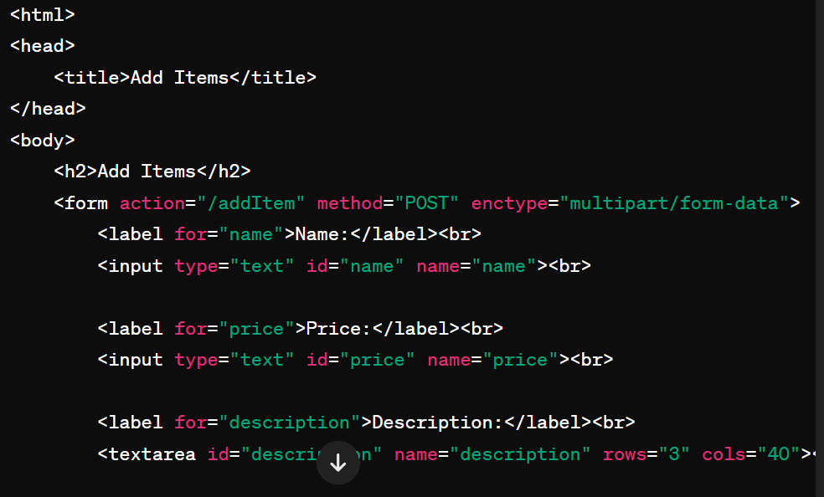

**Update profile**

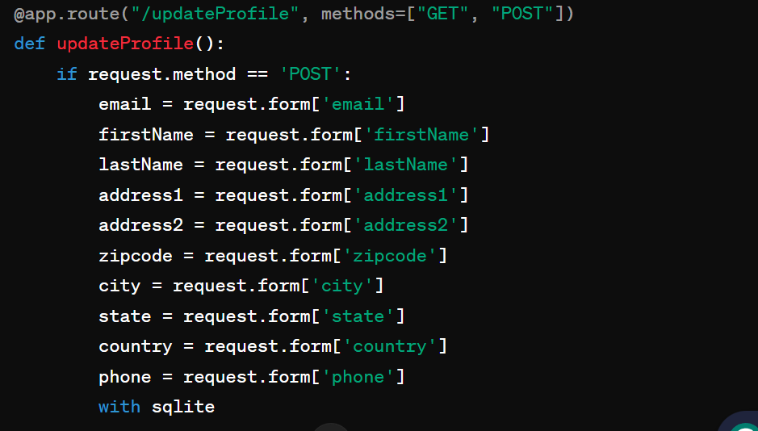

**Change password**

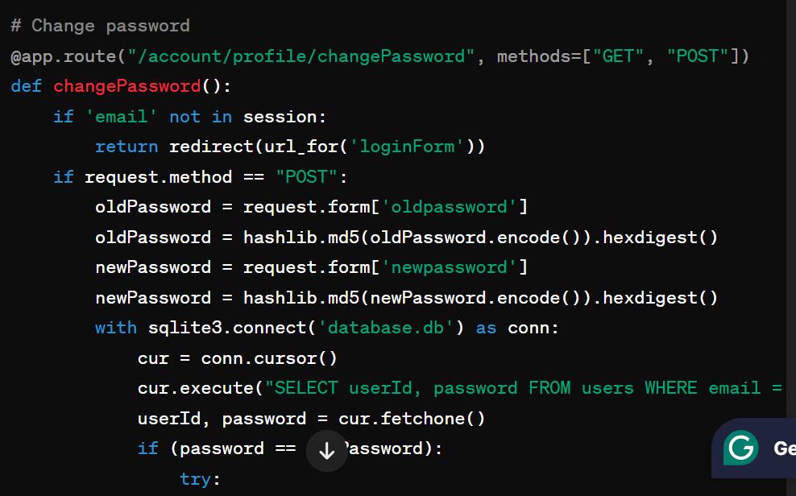

**Add HTML page**

**Edit profile**

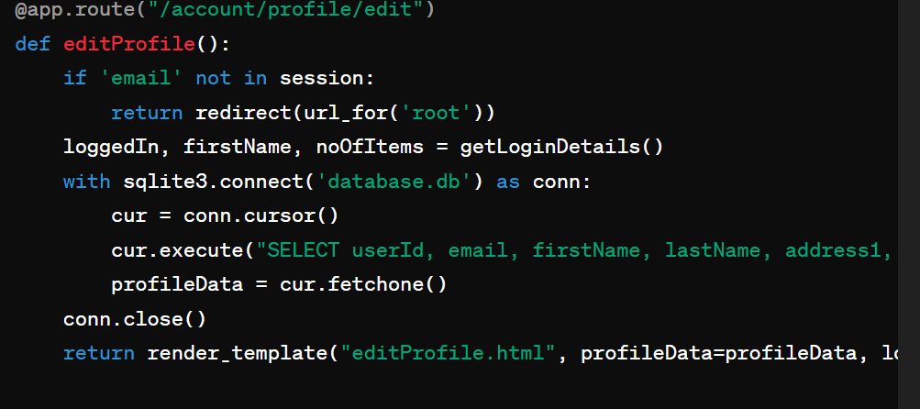

**Add item**

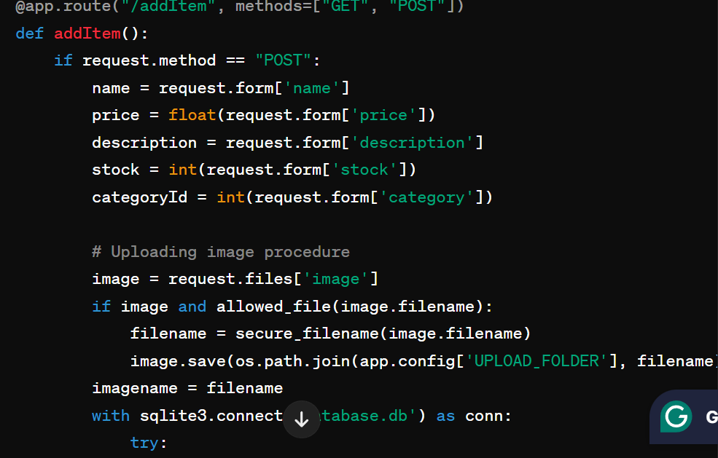

**Upload image procedure**

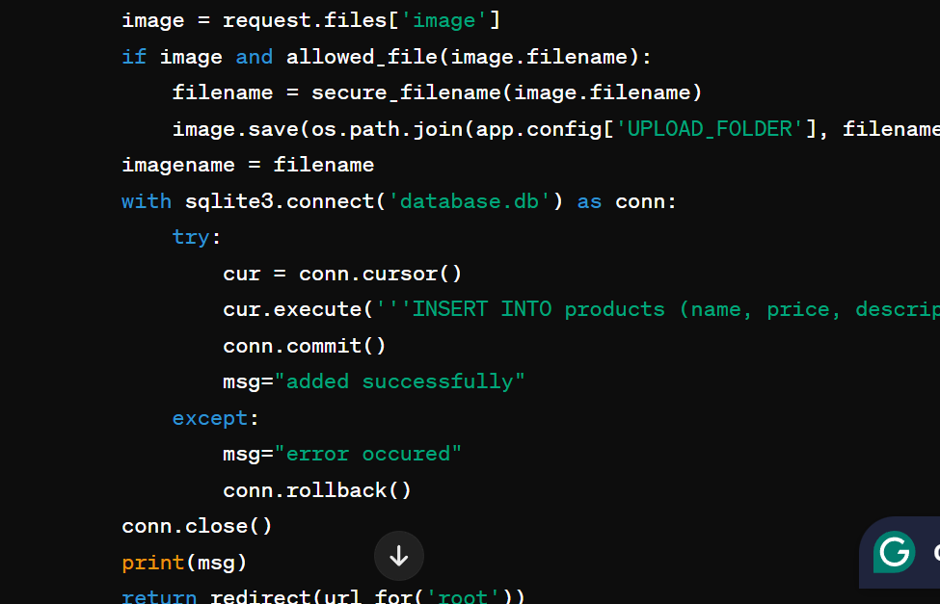

**Home page**

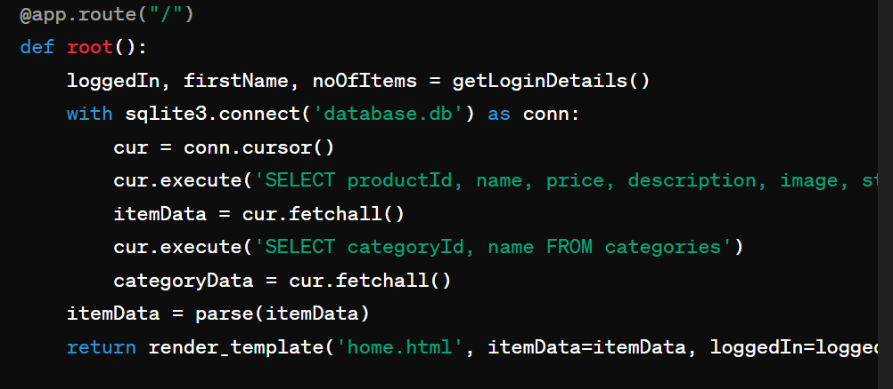

**Get login details function**

